My Pet DJ
By Mya Rana-Nippak

Hi! My name is Mya and I have a little Chinese Crested Maltese mix puppy named DJ. When we first got DJ, the feeling was almost surreal. I had been begging for a dog for what seemed like forever, and now my dream was finally coming true! The story of getting DJ is a long one, but here it goes:
THEN:
One day, just a week before Christmas day, I took the Monday before Christmas break off of school to go to the dentist. At that point in time, I was eight years old and all I thought or read about was puppies and dogs. My favourite book series was the Puppy Place by Ellen Miles and my dad had bought me the whole collection because I loved them so much. That time seems so far away now, since it was almost a year ago. Anyways, after we went to the dentist, my dad suggested we go to the mall, since Christmas was approaching us fast and we still had a few gifts left to buy. When we arrived at Scarbourgh Town Centre, my dad and I went to Sears, in search for jewelry for my mother. She would meet up with us in the food court in several hours and we wanted to get her gifts done before she joined us. So we spent a half hour looking for necklaces for my mom, and finally we found a silver cross that would look precious around her neck. We headed off toward the food court to find my mom, and when we did mom told us she was starving. So my dad asked me what I wanted to eat. “A sub”, I replied, smiling my toothless grin. Dad headed off toward Subway and mother asked me if I had been a good girl at the dentist. I nodded and smiled again. When daddy returned with the subs, mom and I split one. After that, I wanted to go to PJ’s Pet Store to see the fuzzy rabbits and the curious cats. When we arrived at the store, I ran straight to the cats. A certain tuxedo cat caught my eye and I asked my parents if I could get it. I already knew the answer, since I’d already asked for a pet several times before. “Um…” my mom turned to my dad. “Please”, I said. Then I listed all the pros of getting the cat. “I’ll be more responsible, feeding the cat, cleaning the cat and playing with the cat”. My dad couldn’t argue with that, I thought. But then again, he had done it before. “Alright”, my dad said, finally. I was so shocked and surprised that I almost fell over, right there in PJ’s Pets. Mom asked the worker nearby about the cat, and minutes later we were at the counter, paying for the cat, and the stuff. “Mom”, I said. “I think a good name for the cat would be Maxwell. Max for short”. Mom and dad both liked the name, and soon that’s what we were calling him. Everything was perfect
Until the next morning when my mother claimed allergic to Max. “My head spins and I feel so dizzy around him. I’m sorry honey”, mom said. I burst into tears. Dad packed Maxwell up into his carrier and was about to head out the door to STC when his iPhone vibrated with a call from my grandparents. “We’ll keep him”, my grandma announced. I was so happy. Mom had said minutes before that if Max was gone, we could get a puppy. I was a little happier at that news, but now I was extremely happy. Now we would get a pup and still keep Max, at least at my grandparents’ house.
Mom had spent all the night before on Kijiji looking for breeders. She found one only half an hour away and, after reading tons about the breed and looking at pictures, we headed off to the breeder’s house. We arrived in no time and I hopped out of the car, so excited. When we arrived, the breeder welcomed us and let me and my sister hold the pups. My brother, who was 4 at the time, was scared of puppies and dogs, so he stayed in the car with his DS. I got the more energetic one of the two, and he kept squirming in my lap. He had perfect black and white stripes, and was just a bit bigger than the one my sister was holding. I fell in love instantly and asked if we could get him. “I think we should get the calmer one”, dad said. “The one you’re holding could be too much to handle for our family”. My sister and I traded pups and I fell in love with the all black and much chiller puppy too. Dad and mom asked a whole bunch of questions and it felt like forever, sitting on the big black couch. Finally we were going home. The breeder suggested I zip the pup into my winter jacket so he would keep warm in the freezing snow. It was so cute, DJ (or at that time “puppy”) zipped into my jacket, snuggled up against me. I felt cozy. Inside the car, dad blasted his music. The puppy was sort of dancing and since it was a DJ mix on the radio, and we were thinking of names, I suggested DJ. Dad liked it, so we kept it.
Later on, when we introduced DJ to Alia (my big sister) she started being overprotective and wouldn’t let me hold DJ any more. We got into a small disagreement, so mom suggested we go back to the breeder to get the other dog. So later on, mom and dad set out for the breeder’s house again.
What I was told when they got back was that there was another person fighting for the pup, but the breeder knew we were a family and handed mom and dad the pup, which we soon donned Lucky.
Two days after this happened, we ran into problems with Max. He kept jumping on grandma’s furniture, and she was fed up so we had to give Max back to the pet store. I cried a little, but dad reminded me that I had two new pups.
A day later, dad said that the family just couldn’t keep the commitment of two dogs, so Lucky went back to the breeder’s place and now we only had DJ. Christmas was over by this time and I was upset about giving Lucky and Max away, but thankful to god for DJ. He’d given me everything that I wanted that Christmas, a puppy, but also a wonderful Christmas memory that I would cherish my whole life, until I die
NOW:
DJ is now one year old. He turned one a couple months back in October. My family just wasn’t ready for the dog and the commitment, so my Nana and Papa (the same grandparent’s that took Max) welcomed DJ into their home. He lives a happy life here, my Nana cooking sausages and bacon every day for him to enjoy and Papa taking him out for long strolls around the block and to the park. We visit Nana, Papa and DJ about three to five days a week, so I still get plenty of chances to interact with the puppy that was meant for me.
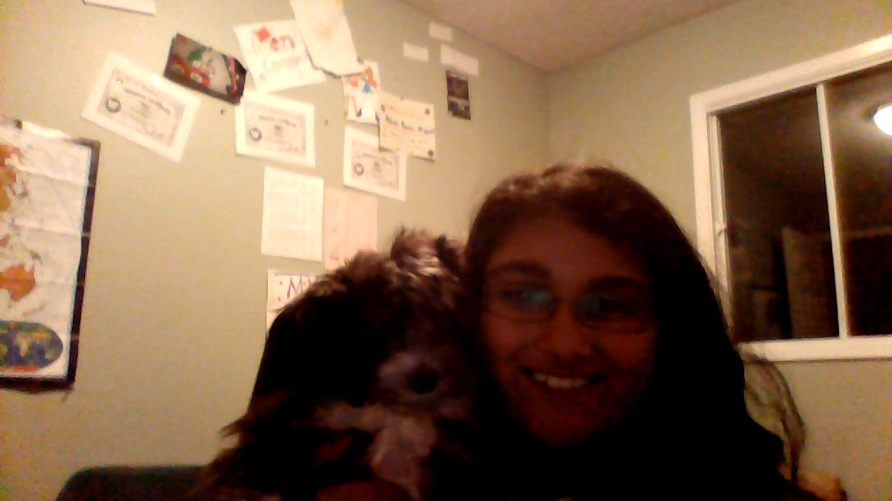
This is a picture I took of DJ and me on my laptop today, one of those 3-5 days a week I spend with him!
Quick-fire:
DOB: October 1st 2011
Full Name: DJ Rana-Nippak
Favorites:
Toy: any cat toy
Food: Nana’s roast beef
Person: Papa, me, my mom or my dad
Place to sleep: the rocking chair by the window so he can see all the cars and people pass by
Place: my Nana and Papa’s house or anywhere outdoors
Pastime: eating, sleeping, going on walks and chewing on anything

And now you know all there is to know about DJ! Thanks for reading this. DJ may just be an ordinary dog, but to me, he’s more. He’s a friend, companion and maybe even more.
-Mya Rana-Nippak (9)
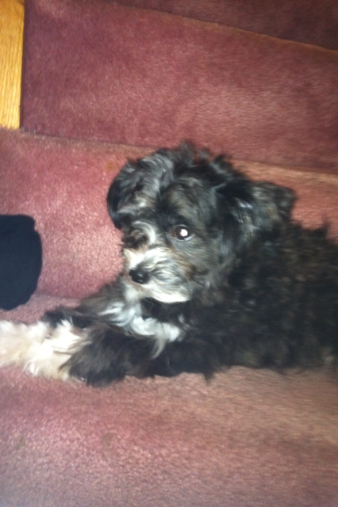
DJ lying on the steps at Nana’s and Papa’s!
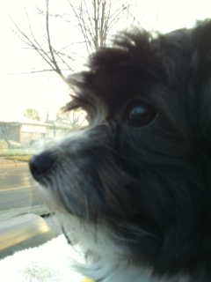
DJ in Papa’s car, he just love car rides!
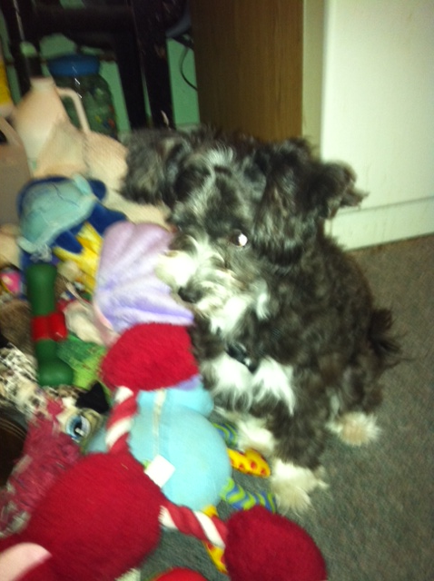
DJ playing with his toys, the red one in the front is his favorite!

